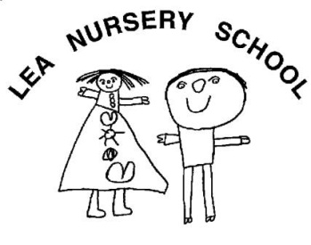
Early Years Practitioner
Salary  Hours | Slough Borough Council Level 5  33.5 hours per week (term time only)
Location | Lea Nursery School
Contract type | Permanent
Qualification | CACHE Diploma Level 3 in Child Development or equivalent qualification  3 years minimum experience in a school or nursery with SEND experience necessary.  Previous applicants or employees need not apply.
The Governors of Lea Nursery school are looking to appoint an enthusiastic person with excellent interpersonal skills who enjoys working with children aged 2-5 years of age in a play based curriculum.
Applications are invited from suitably qualified and expereinced people to join our friendly and dedicated team.
The successful candidate’s responsibilities would include:
- Settling children.
- Ensuring children are cared for and educated in a happy, secure and stimulating environment that acknowledges the importance of parental involvement.
Please note that DBS clearance is essential for this post
To apply please completed application form email to head@lea-nursery.slough.sch.uk
For further details, please talk to Linda Stay.
Closing date: 31 May 2024
Interview date: TBC

Lea Nursery School
Wexham Road
Slough SL2 5JW
Tel 01753 536492
Email: post@lea-nursery.slough.sch.uk
Website: www.lea-nursery.slough.sch.uk

