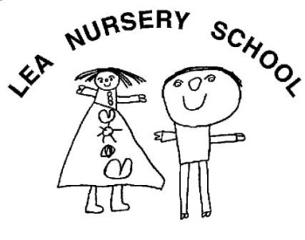

**Early Years Practitioner**

|  |  |
| --- | --- |
|  |  |
| Salary  Hours | Slough Borough Council Level 5  33.5 hours per week (term time only) |
| Location | Lea Nursery School |
| Contract type | Permanent |
| Qualification | CACHE Diploma Level 3 in Child Development or equivalent qualification  **3 years minimum experience in a school or nursery with SEND experience necessary.**  **Previous applicants need not apply.** |

The Governors of Lea Nursery school are looking to appoint an enthusiastic person with excellent interpersonal skills who enjoys working with children aged 2-5 years of age in a play based curriculum.

Applications are invited from suitably qualified and expereinced people to join our friendly and dedicated team.

**The successful candidate’s responsibilities would include:**

* Settling children.
* Ensuring children are cared for and educated in a happy, secure and stimulating environment that acknowledges the importance of parental involvement.

**Please note that DBS clearance is essential for this post**

To apply please completed application form email to [head@lea-nursery.slough.sch.uk](mailto:head@lea-nursery.slough.sch.uk)

For further details, please talk to Linda Stay.

Closing date: Friday 11 August 2023.

Interview date: TBC

**Lea Nursery School**

**Wexham Road**

**Slough SL2 5JW**

**Tel 01753 536492**

**Email:** [**post@lea-nursery.slough.sch.uk**](mailto:post@lea-nursery.slough.sch.uk)

**Website: www.lea-nursery.slough.sch.uk**